Final Project Report

ToyLand



Project Supervisor
Neelam Alam

Submitted By

F21020F57E(MC160401595)

Software Projects & Research Section,
Department of Computer Sciences,
Virtual University of Pakistan


CERTIFICATE

This is to certify that <<First Member Name>> (<<VU ID>>), <<Second Member Name>> (<<VU ID>>) have worked on and completed their Software Project at Software & Research Projects Section, Department of Computer Sciences, Virtual University of Pakistan in partial fulfillment of the requirement for the degree of BS in Computer Sciences under my guidance and supervision.

In our opinion, it is satisfactory and up to the mark and therefore fulfills the requirements of BS in Computer Sciences.

Supervisor / Internal Examiner

<<Project Supervisor Name>>
Supervisor,
Software Projects & Research Section,
Department of Computer Sciences
Virtual University of Pakistan

___________________
(Signature)

External Examiner/Subject Specialist
<<External Supervisor Name>>

___________________
(Signature)

Accepted By:

_____________
(For office use)

EXORDIUM

In the name of Allah, the Compassionate, the Merciful.

Praise be to Allah, Lord of Creation,
The Compassionate, the Merciful,
King of Judgment-day!

You alone we worship, and to You alone we pray for help,
Guide us to the straight path

The path of those who You have favored,

Not of those who have incurred Your wrath,
Nor of those who have gone astray.

DEDICATION

I would like to express my gratitude towards my parents & member of Virtual University for their kind co-operation and encouragement which help me in completion of this project. I would like to express my special gratitude and thanks to friends and teachers for giving me such attention and time.

ACKNOWLEDGEMENT

I have taken efforts in this project. However, it would not have been possible without the kind support and help of many individuals and organizations. I would like to extend my sincere thanks to all of them.

PREFACE

Toyland is a toy website for kids. The toys are the important part of kids life. Kids like to play with toys. Every kid like to shop toys of their choice. In the current situation of COVID it is risky for kids to go in the markets without masks to buy toys.

So we are developing the toy land it is e-commerce website where user can buy the kid toys online by watching toy products images, video , description and other detail.

This website has a toy for kids of each age group, and category etc. this website will show the kid toys and toy details. the user can place their kid order online and pay the payment online or cash on delivery. The user can add toy product to the cart and place order. The user can even track the order view the summary of the order.

This website helps the user to search and sort toy product according to their choice, this website will also learn the use of applications and their capabilities to search, select and decide will also be improved.

TABLE OF CONTENTS

CHAPTER NO. 1
gathering & Analyzing info 9

1.1 Introduction

1.2 purpose

1.3 scope

1.4 definitions, acronyms and abbreviations

1.5 use cases and usage scenarios

1.5.1 Use Case Diagrams

1.5.2 Usage Scenarios

1.6 supplementary requirements

1.6.1 Usability

1.6.2 Reliability

1.6.3 Supportability

1.6.4 System Requirements

CHAPTER NO. 2
planning the project 26
2.1 Introduction

2.2 Methodology

  - Available Methodologies

  - Chosen Methodology

  - Reasons for Chosen Methodology

  - Work Plan
  - Project Structure

    - Team Structure

    - Project Schedule (Submission Calendar)

CHAPTER NO. 3
designing the project 32

3.1 Introduction

3.2 purpose

3.3 scope

  - definitions, acronyms and abbreviations

  - Architectural Representation (Architecture Diagram)

  - Dynamic Model: Sequence Diagrams

  - Object Model/Logical Model: Class Diagram

  - Database Model (Database Diagram)

  - Graphical User Interfaces

Chapter no.4
DEvelopment 51
4.1 Development plan (Architecture Diagram)

CHAPTER 1
Gathering & Analyzing Info

  - Introduction

In this modern era of technology a large number people of Pakistan use internet. People spend more time on social media platforms and many people post in urdu language. Many people only know urdu and they also type in urdu.
As we know Urdu is mother tongue of Pakistan and this web application will help and provide a flexible & easy platform to users to post their questions in urdu language, and the other users of application will answer the posted questions in urdu. The guest user can see the questions and their answers, and also find his/her question & answer. This type of application will promote Urdu language in Pakistan and will tend people to use & comminacte with others in urdu.

This web application will provide:
- Registered user can post question in urdu
- Registered user can answer the posted question in urdu.
- Registered user can mark answer as correct the already posted answer.
- Guest user can see posted questions & answers on application and also search questions and their answers.

  - purpose

The purpose of the website is to provide an online platform to post their question in Urdu language as Urdu is a mother tongue of Pakistani and people found it easy to read and write in Urdu language in websites. This website provides an online website people can post their question and can get the answers of their question in Urdu language. This platform makes it easy for the people to enter Urdu content in the website. It provides an easy and secure way of registration so the users can easy it easily. The user can easily get the answers of their question.

1.3 scopes

This system has a scope because it can be used in market place for the people who can post the question in Urdu language.it has a scope because it provides a Urdu platform so the Urdu language user can found it more attractive and interesting to use.

Functional and non-Functional Requirements:

Functional Requirements:

Functional Requirements:

There will be three type of users:
- Admin
- Registered User
- Guest User (Unregistered user)

Admin:
Admin will able to edit or delete question/answer and also user. Admin should set the number of English words are allowed to use while posting question/answer.

Registered User:
Registered user can see & post questions and answer the posted questions.

Guest User (Unregistered user):
Guest user only can use posted questions/answers and search questions/answers according to need.

Modules:

Registered User Module:
- User Registration and Sign In: There will be a registration form where user can register by providing information. A registered user will able to login into application by enetering credentials.

- View and Search Questions/Answers: The registered user can see posted questions/answers and also search questions.

- Post Question: The registered user can post question in urdu with limited amount of English words.

- Post Answer: The registered user can post the answer of posted question of other user in urdu with limited amount of English words.The registered user can only post answer of other user and not able to post answer of own question.

- Edit and Delete Question: The registered user can edit and delete his/her posted question and answer.

- Correct the Answer: The registered user can mark answer as correct the posted answer and make it more helpful for others.

- Manage Profile: The registered user can manage his/her profile.

Admin Module:
- Login: Admin can login into site by entering valid credentials to access and manage site.

- Manage Users: Admin can edit and delete user.

- Edit and Delete Questions/Answers: Admin can edit any question/answer and also can delete any question/answer.

- Set Limit: Admin can set the limit for use of English words.

Guest User Module:
- See Question/Answer: The guest user can the see homepage where he/she can see the posted question/answer.

- Search Questions: The guest user can search question according to need and will find answer according to question.

Order of content:
The order of posted questions/answers should be display in date-posted order.

Search & Search Result:
The search have filters and search result will display title of question, preview text etc.

Non-functional Requirements:

This application will have following non-functional requirements:

- User Interface: Homepage of site will be eye catching and simple so every type of user will easily use application.
- Performance: The performance of site should be good and especially while searching the result the speed should be good.
- Capability & Availabilty: The site should be able to manage multiple and large number of users and should be available for users everytime.
- Maintainance: Site should easily maintainable.

  - definitions, acronyms and abbreviations

CSS: Cascading Style Sheets: Without CSS, the web would be a lot more boring. CSS is a language of rules that affect the style of HTML content. When a website uses consistent colors, fonts, and layouts across multiple web pages, this was accomplished with CSS. It’s like the icing on top of a cake built with HTML.

HTML: Hypertext Markup Language. This is the first part of front end development that many people know the basics of. It is used to design the layout of the webpage.

CRUD : create, read, update , delete. It is the database query to performance database queries on the data of the database in mysql database.

PHP : it is personal home page. It is open script and common free language used in web development to create dynamic pages.

1.5 use cases and usage scenarios

1.5.1 Use Case Diagrams

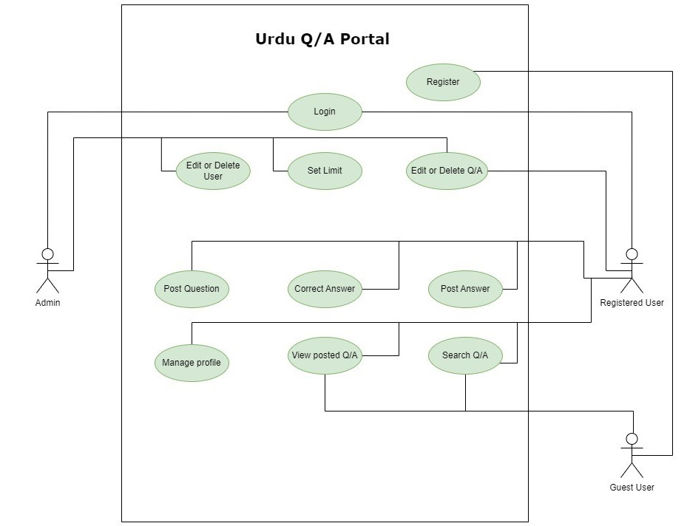

1.5.2 Usage Scenarios

  - supplementary requirements

Usability: Usability defines how well the application meets the requirements of the user and consumer by being intuitive, easy to localize and globalize, providing good access for disabled users, and resulting in a good overall user experience.

Performance: Application should be designed and developed in such a way that it should not utilize too many resources.

Secure: registration and login system should be safe and secure.

Friendly interface: this app has a friendly interface. Simple and easy to use. The user can easily use it.

Maintain: the app is proper maintain from time to time.

    - Supportability:

System must be accessible from all kind of bowser.

1.6.4 System Requirements

- 64-bit Microsoft® Windows® 8/10.
- x86_64 CPU architecture; 2nd generation Intel Core or newer, or AMD CPU with support for a Windows Hypervisor.
- 8 GB RAM or more.
- 8 GB of available disk space minimum
- 1280 x 800 minimum screen resolution.

CHAPTER 2
Planning the Project

2.1 Introduction:

A project has a lifecycle, underpinned by a plan, which is the path and sequence through the various activities defined to produce its products.
Project management primarily focuses on planning, managing and organizing the available resources. Initiation defines project goals and objectives. · Planning sets out the project scope. · Execution is when the deliverables are created

2.2 Methodology

A methodology is a collection of methods, practices, processes, techniques, procedures and rules. In project management, methodologies are specific, strict and usually contain a series of steps and activities for each phase of the project’s life cycle. They are defined approaches that show us exactly what steps to take next, the motivation behind each step, and how a project stage should be performed.

  - Available Methodologies

The two main methodologies are:
1. Waterfall Model.
2. Spiral Model.

Waterfall Model:

The waterfall model was the first process model to be introduced. It is very simple to understand and use. It is also referred as a linear sequential life cycle model. The waterfall model illustrates the software development in a linear sequential flow. In waterfall model whole software development process is divided into separate phases. This means that any phase in the development process begins only if the previous phase is complete. This model is depicted under the diagram

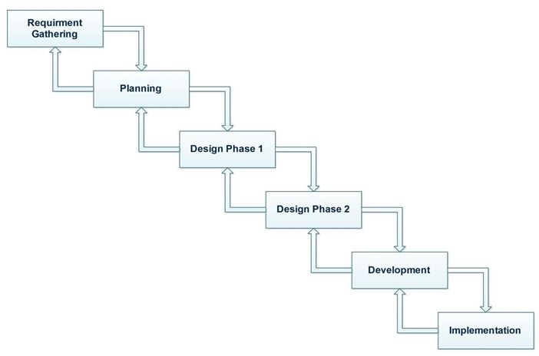

The waterfall Model has a five phases these phases are explain below:

1. Requirements Analysis and definition:

All the requirements of the system is captured in this phase and documented in the requirement specification document.

2. System and software design:

All the requirements gather in the first phase are studied in this phase and design is prepared according to the requirement. This system design helps in specifying hardware and system requirements and defining the overall system architecture.

3. Implementation and unit testing:

From the system design, the system is developed in small programs called units. Each unit is developed and tested for its functionality which is known as unit testing.

4. Integration and System testing:

All the units developed in implementation phase are integrated into a system after testing. In this phase the entire system is tested for any faults and failures.
When the functional and non-functional testing is done, the project is deployed in the customer environment or released into the market.

5. Operation and Maintenance:

If issues come up after the delivery of the project or in the client environment, those issues and errors are fixed in this phase. Maintenance is done to deliver these changes in the customer environment.

Spiral Model :

It is a combination of waterfall model and iterative model.it is a risk driven software development model. It helps to adopt software development elements of multiple process models for the software project based on unique risk patterns ensuring efficient development process.

Each phase of spiral model in software engineering begins with a design goal and ends with the client reviewing the progress. It starts with a small set of requirements and goes through each development phase for those set of requirements. This model is depicted under the diagram

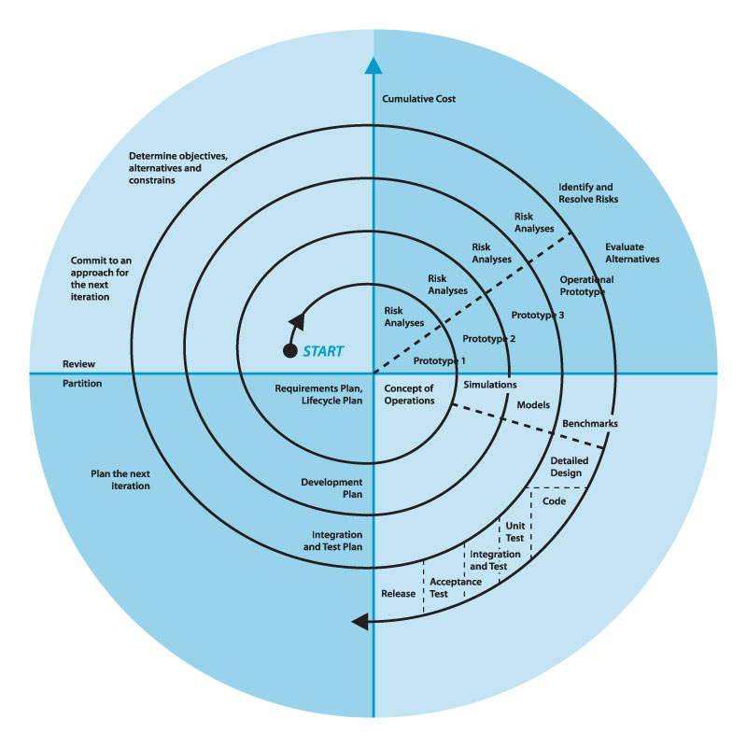
The spiral model has four phases.
1. Planning:
In planning phase it includes estimating the cost, schedule and resources for the iteration. It also involves understanding the system requirements for continuous communication between the system analyst and the customer.
2. Risk Analysis:
Identification of potential risk is done while risk mitigation strategy is planned and finalized.

3. Engineering:
It includes testing, coding and deploying software at the customer site.

4. Evaluation:
Evaluation of the software by the customer. Also, includes identifying and monitoring risks such as schedule slippage and cost overrun.

  - Chosen Methodology
VU Process Model:

Vu process is a combination of waterfall and spiral model. It is also called Hybrid approach of system development. It minimizes risks and errors and maximizes the quality of system. It has five phases which are:
- Analyzing Requirement phase
- Design phase
- Implementation
- Integration and testing phase
- Maintenance and operation

Vu process model diagram:
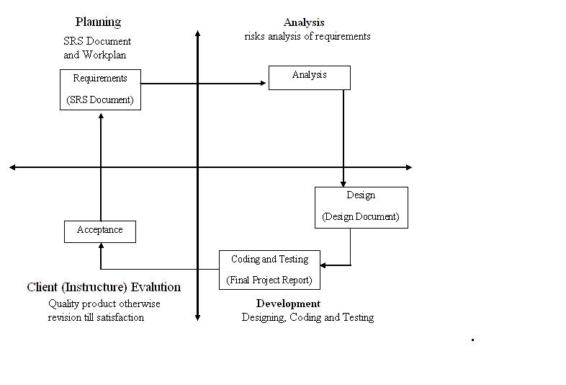

  - Reasons for Chosen Methodology

Following are the reasons for choosing VU process model:

- Vu process model is easy to use and helpful for my project.
- It is a combination of two models spiral and waterfall so get the advantages of both the model.
- All the activities are performed in a sequence.
- It is sequential model with backward repetition.
- Project is divided into many phases. So in vu process model we will work in phases to complete the given model.
- It is error free result as each step is done in a sequence.
- If errors or mistakes are found, it suggests correcting the error or mistake and improving the project.

  - Work Plan

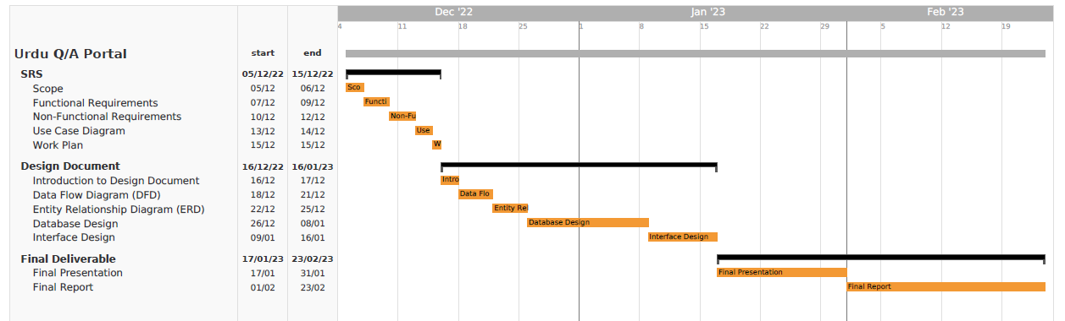

CHAPTER 3
Designing the Project

3.1 Introduction

The Software Design Document is a document to provide documentation which will be used later in software development by providing the details for how the software should be built.

Within the Software Design Document are narrative and graphical documentation of the software design for the project including use Entity Relationship Diagram (ERD), Sequence, Diagrams, Architecture Design Diagram, Class diagram, Database Design, Interface Design and Test Cases.

3.2 purpose

The purpose of the Software Design Document is to provide a description of the design of a system fully enough to allow for software development to proceed with an understanding of what is to be built and how it is expected to build. The Software Design Document provides information necessary to provide description of the details for the software and system to be built.

3.3 scope

There are many benefits of a well-defined design document some of those are:
User’s expectation of the system is documented properly and helps a lot later while developing the site. All major design issues are discussed. Different analysis on the system can be performed. It saves a lot of time of the developer when all the functionality of the system is captured properly and is documented in a file.

3.5 Architectural Representation (Architecture Diagram)

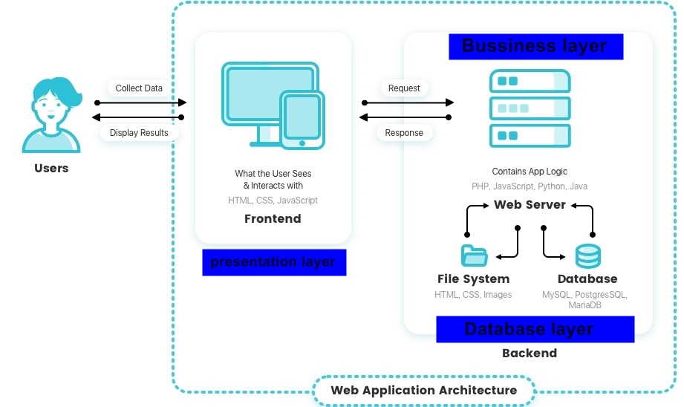

3.6 Dynamic Model: Sequence Diagrams

- Sequence Diagrams
1. register
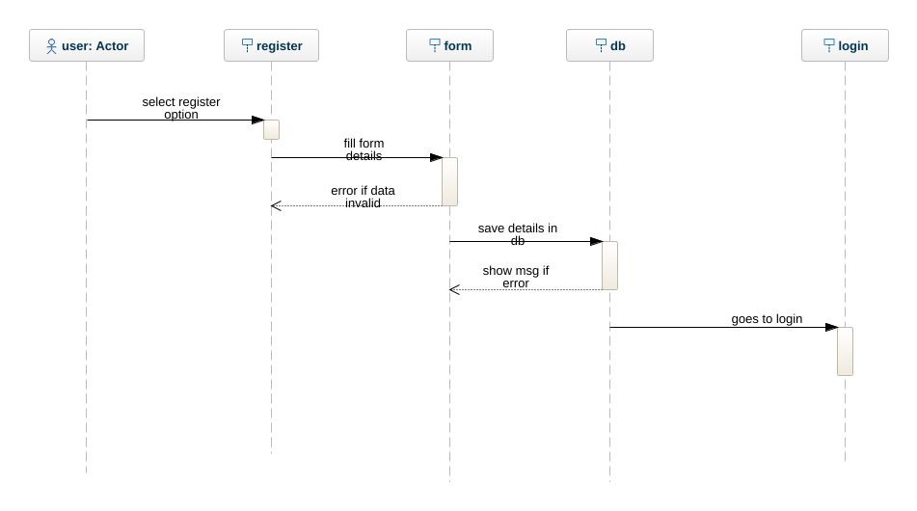
2. login
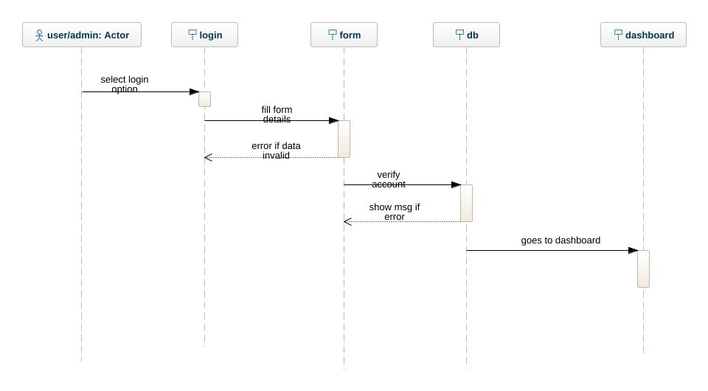

3. view product
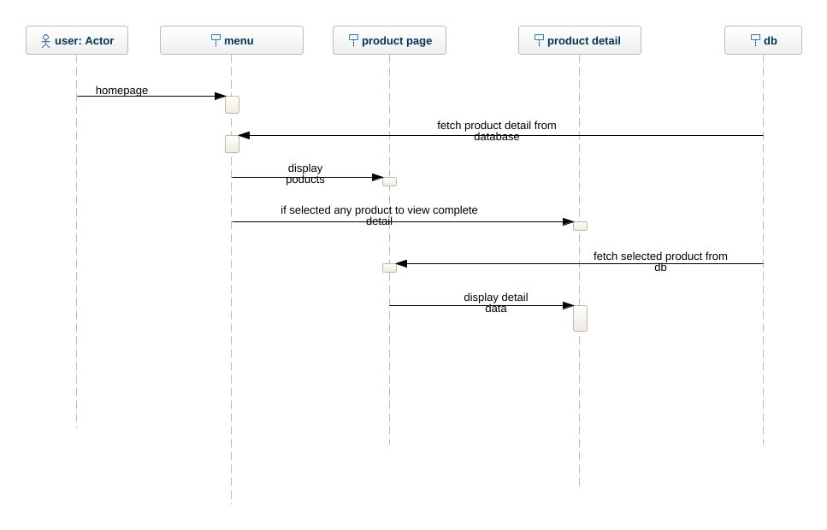
4. select product
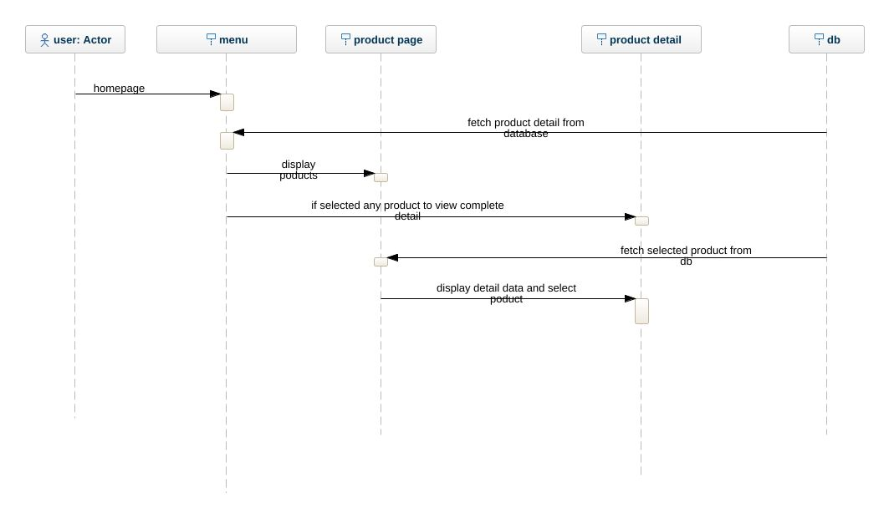

5. add to cart
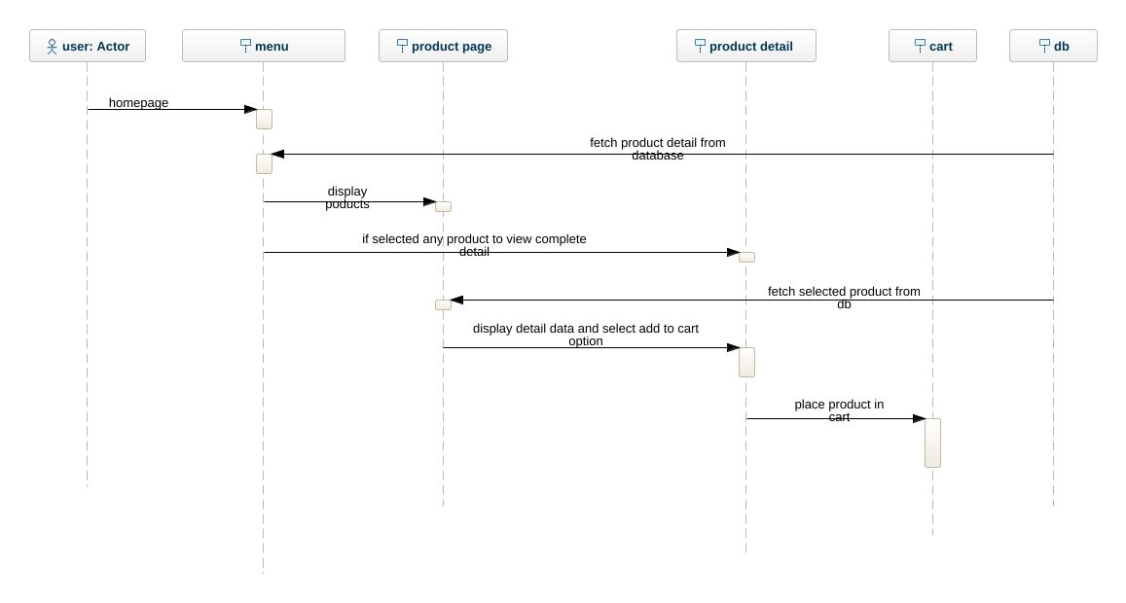
6. place order
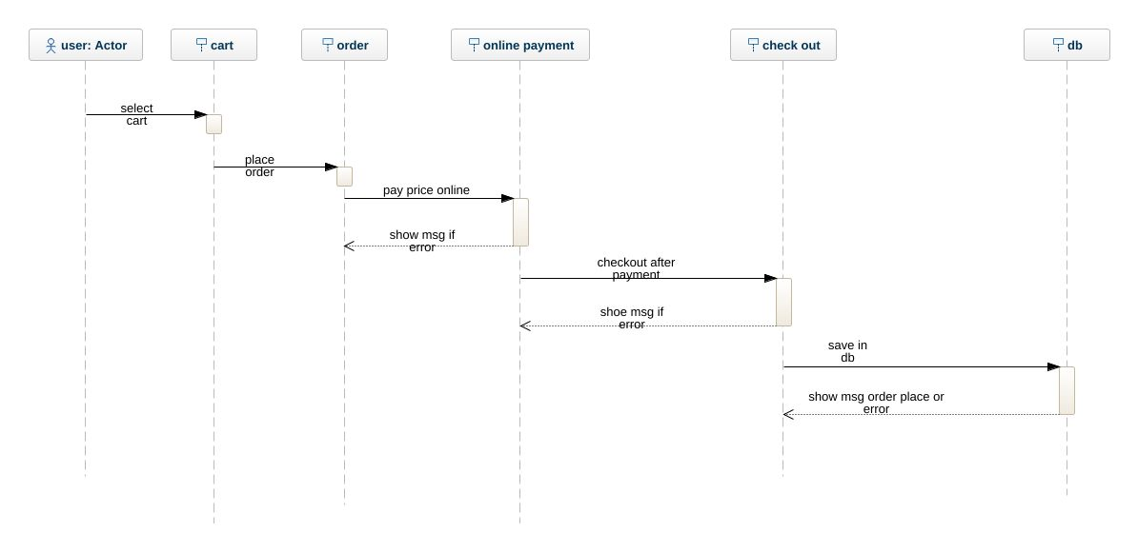
7. track order
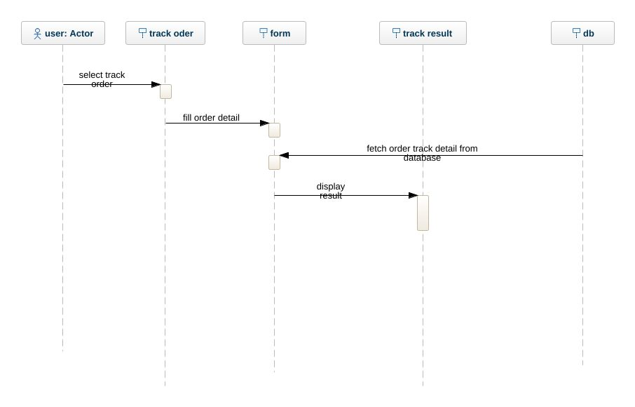
8. logout
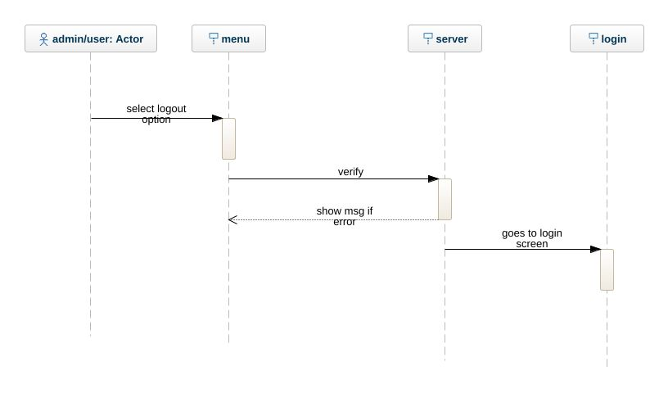

9. manage category
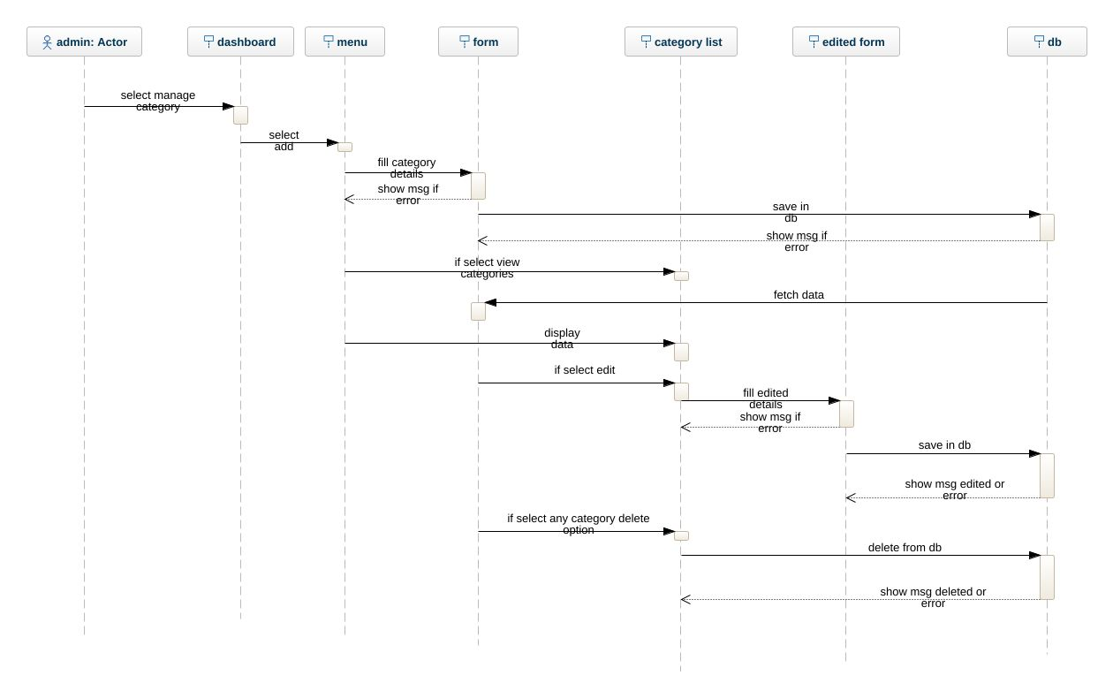
10. manage product
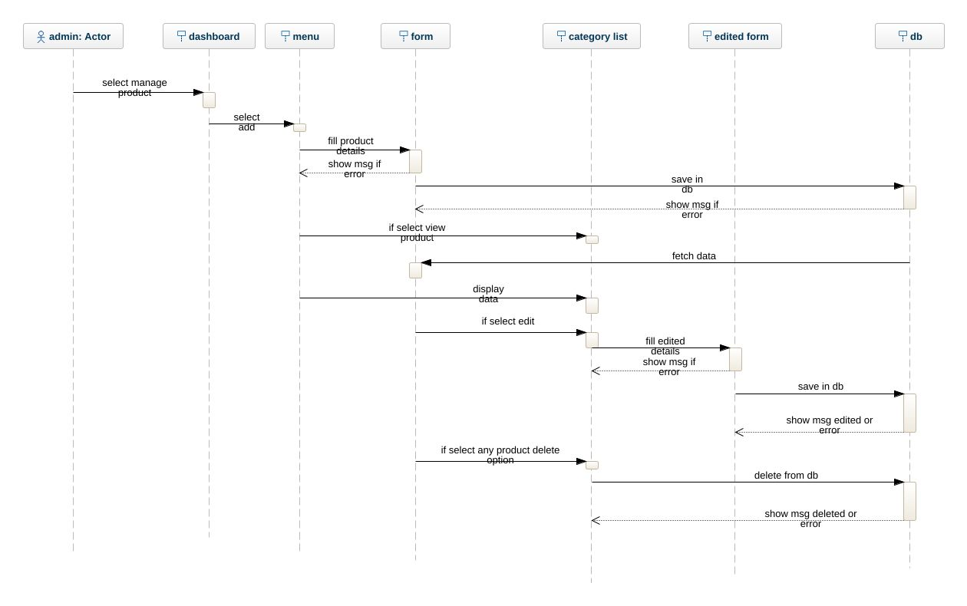

11. view orders
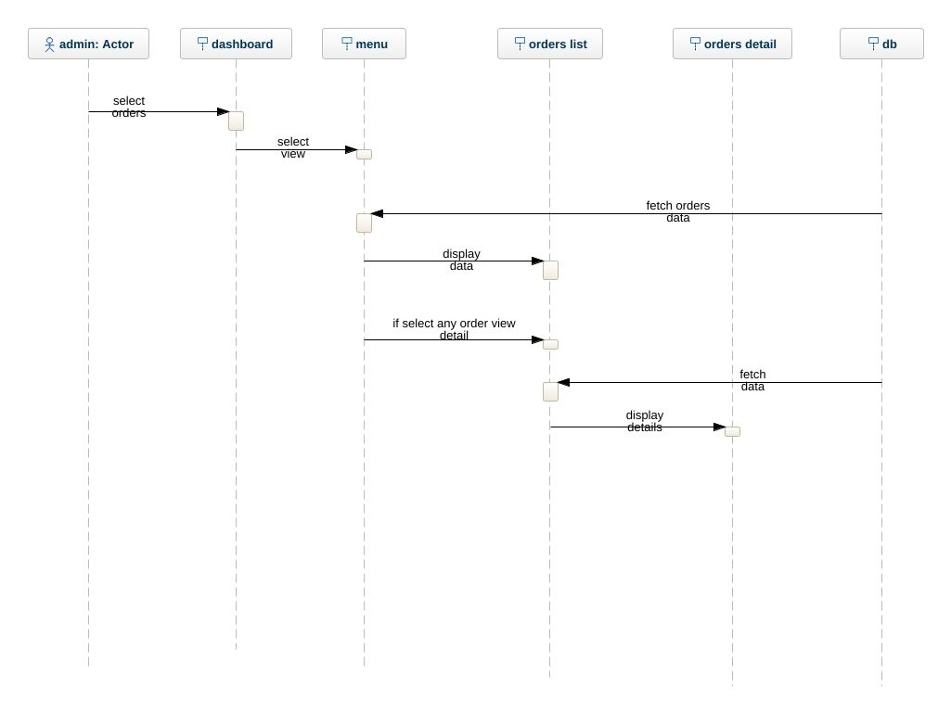

  - Object Model/Logical Model: Class Diagram

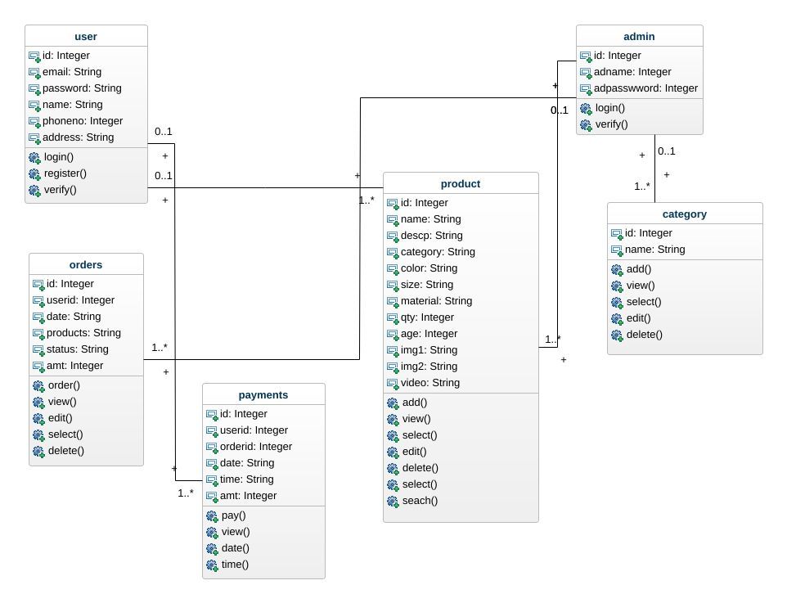

  - Database Model (Database Diagram)

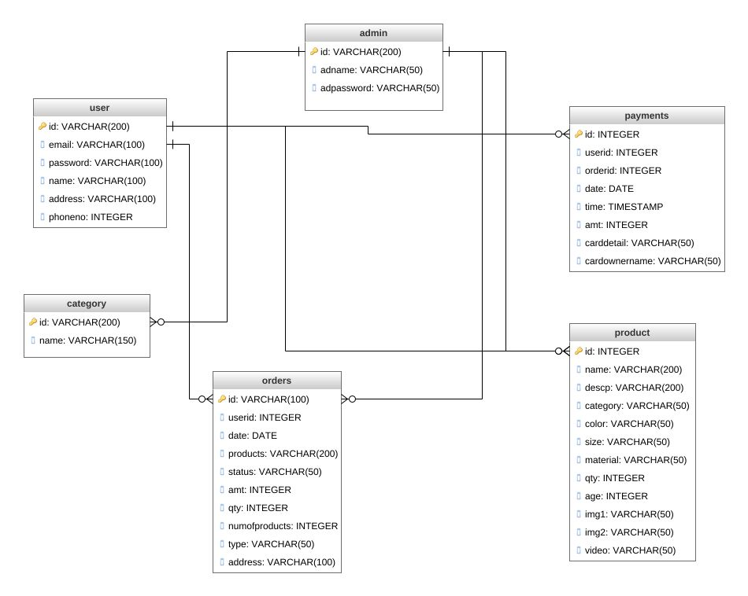

CHAPTER 4
Development

4.1 Development plan (Architecture Diagram)

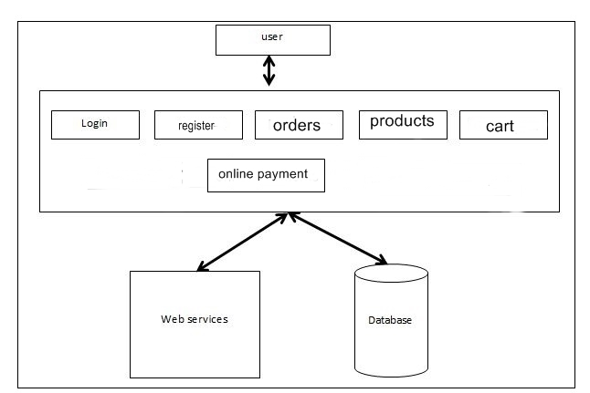

REFERENCES

[1] History of PHP - Manual. (2019). Retrieved from:
https://www.php.net/manual/en/history.php
[accessed: 17 May 2019].
[2] ASP.NET Community Standup. (2019). Retrieved
from: https://live.asp.net/ , [accessed: 19 May
2019].
[3] Comentum Corp. (2010, August 1). PHP vs ASP.net
Comparison. Retrieved from:
https://www.comentum.com/php-vs-asp.net-
comparison.html , [accessed: 10 March 2019].
[4] Sebesta, R. W. (2015). Programming the World Wide
Web 8th edition. Boston: Addison-Wesley.
[5] ASP.NET and PHP Support. (2019, January).
Retrieved from:
https://www.iis.net/overview/choice/aspnetandphpsup
port [accessed: 03 June 2019].
[6] Naim, R., Nizam, M. F., Hanamasagar, S.,
Noureddine, J., & Miladinova, M. (2010).
Comparative Studies of 10 Programming Languages
within 10 Diverse Criteria. Artigo publicado no
COMP, Montreal-QC, Canadá. Montreal.
[7] Total number of Websites. (2018). Retrieved from:
https://www.internetlivestats.com/total-number-of-
websites/. , [accessed: 05 June 2019].

APPENDIX

CSS Cascading Style Sheets: Without CSS, the web would be a lot more boring. CSS is a language of rules that affect the style of HTML content. When a website uses consistent colors, fonts, and layouts across multiple web pages, this was accomplished with CSS. It’s like the icing on top of a cake built with HTML.

HTML Hypertext Markup Language: This is the first part of front-end development that many people know the basics of. Even if you aren’t technical, you may have used HTML to edit an email layout or change the text on a web page.

CRUD Create, Read, Update, Delete: If someone is learning how to build a CRUD app, they aren’t learning how to build a terrible one. They’re learning how to build an app that completes these four basic functions.

PHP Originally Personal Home Page, but renamed to PHP Hypertext Preprocessor: PHP is a common free and open-source script language used in web development.

